Mahathma Gandhi College,Thiruvananthapuram-695004
Department of ………HISTORY…………

Name : LATHA. G. NAIR 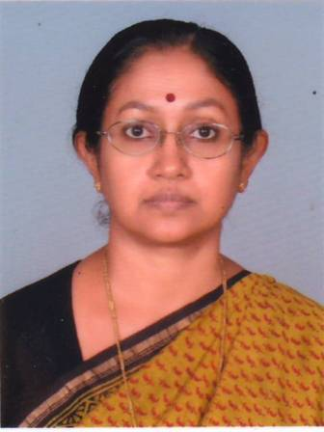
Designation : Assistant Professor & Head
Address : 16 A, Windbrook Place,
Althara Juncion, Vellayambalam
Thiruvananthapuram-695010
Email ID : latha_anup@yahoo.co.in
Web site if any
Blog if any
Landline no : 0471- 2723879
Mobile no : 9497772096

Academic qualifications: MA, M.Phil
Place of study: Government College for Women, Vazhuthacaud, Thiruvananthapuram.
Thesis topic:
Areas of interest: Kerala History
Research papers published:
Patents filed:
Books /chapters published:
Articles published in periodicals /magazines
Paper presentations:
Invited Talks given:
Topics for invited talks:
Whether an approved guide of the University:
PhD awarded and title of thesis:
No of students currently registered for PhD:
Major Research Projects carried out :
Major Research Projects ongoing:
Minor Research Projects carried out:
Minor Research Projects ongoing:
Extension activities:
Consultancy:
Memberships in Professional/Academic bodies:
Awards/Recognitions:
Seminars and workshops organized:
Seminars and Workshops attended:
Any other relevant information:

Name: LATHA. G. NAIR Signature:

