Department Programme 2017- 2018
Organised a Poster Exhibition in connection with Quit India Day on09/08/2017.
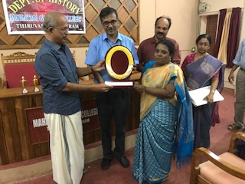
Organised a Quiz Programme and a Seminar in connection with Independence Day on 17/08/2017.
Complimenting Dr. Bindu K Ravi for getting Ph. D. by Dr. MG Sasibhooshan and Principal, Dr. M.R. Sudarsanakumar.

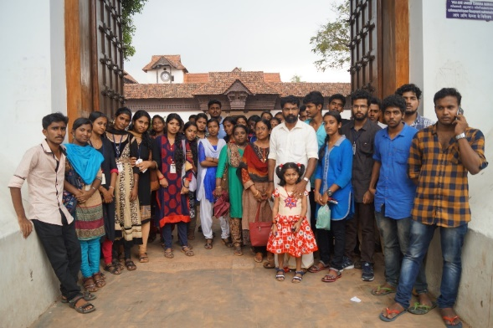
Conducted a site visit to Sree Padmanabhapuram Palace and The Madhavi Mandiram Loka Seva Trust Musium and Heritage for Gandhian Studies, Neyyattinkara on 27/10/2017.

S5 History students in front of Sree Padmanabhapuram Palace

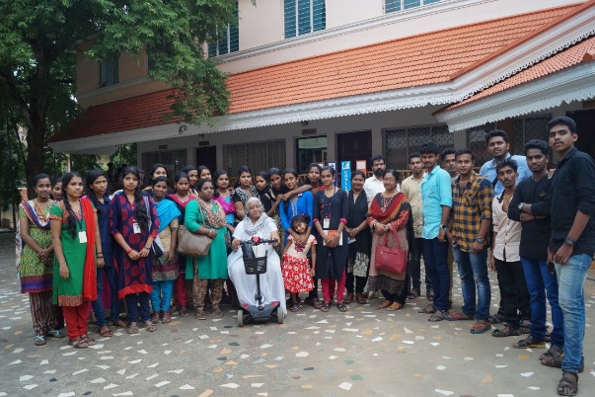

S5 History Students in front of Madhavi Mandiram Loka Seva Trust Musium and Heritage for Gandhian Studies, Neyyattinkara

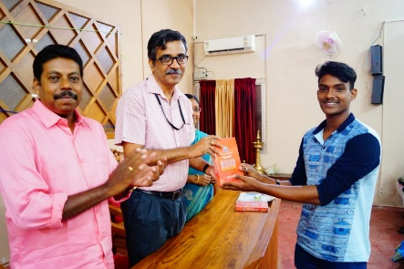
Conducted an Elocution Competition and Talk by Dr. Robindson Jose K, Assistant Professor, Department of History, University College, Thiruvananthapuram, in connection with HRM Nation Salutes Sardar Vallabhbhai Patel on 31/10/2017.

ALUMNI ASSOCIATION MEETING (14/12/2017 Thursday)

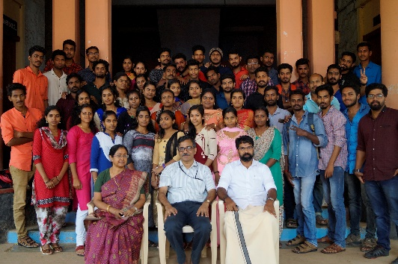
Session I

Prayer Ms. Anjitha Sunil B

Acharyanusmaranam

Welcome Smt. Latha G Nair

Presidential Address Dr. M.R. Sudarsanakumar (Principal)

Facilitations
Dr. VM Anandakumar (Council Secretary)
Dr. MS Anil Kumar (IQAC Co coordinator)
Dr. Harikumar. S (Department of History)

Vote of Thanks Yadu Krishnan KU

Session II

Future plans and actions of the Association

